
Year 1
Art - Fabric Houses

Key Vocabulary
Exploring and developing ideas | Look carefully at photographs and images of houses.
Draw a house | Create and develop ideas using colours, lines, shapes, textures and patterns.
Collage | Cut and tear paper and card for their collages.  Gather and sort the materials.  Look at the effect of dye on different textiles.  Use a wide variety of media, inc. photocopied material, fabric, plastic, tissue, magazines, crepe paper.
Print | Print onto paper and textile.  Design their own printing block.  Create a repeating pattern.  Recognise pattern in the environment
Evaluate | Review what they and others have done and say what they think and feel about it.  Identify what they might change in their current work or develop in their future work.
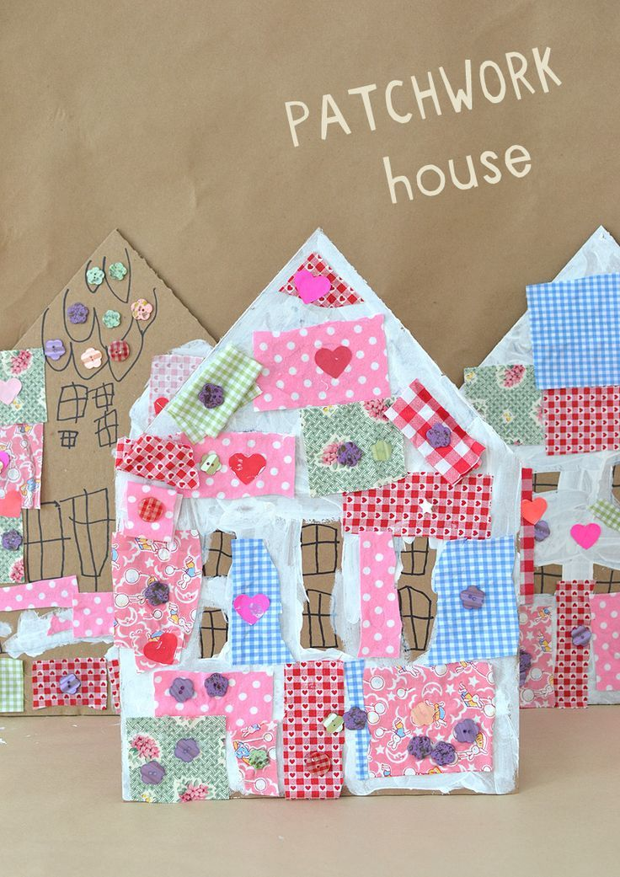
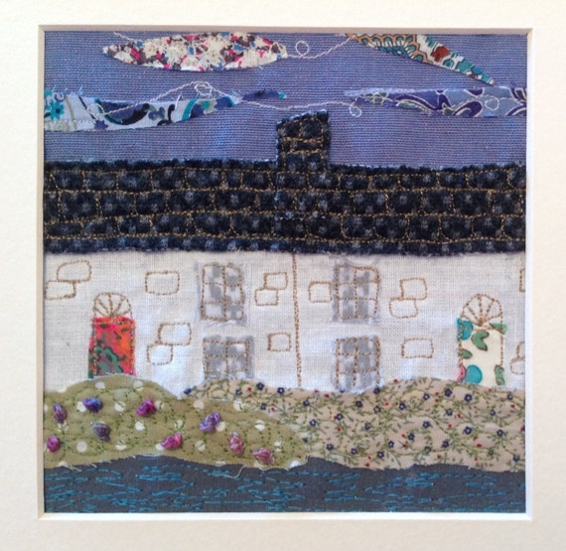
What techniques did you use?
Would you make any changes to your house? How would you do this?

Are you a Milecastle Megamind?

Can you explain how to make a patchwork house?

