
Year 1
Homes – Sliders and leavers

Key Vocabulary and skills
Design | Suggest ideas and explain what they are going to do  Model their ideas in card and paper.
Make | With help, measure, mark out, cut and shape a range of materials.
Evaluate | Use simple finishing techniques to improve the appearance of their product.
Slider and Lever | To explain a range of sliders and levers
Product | An Easter card with a chick moving using a slider.
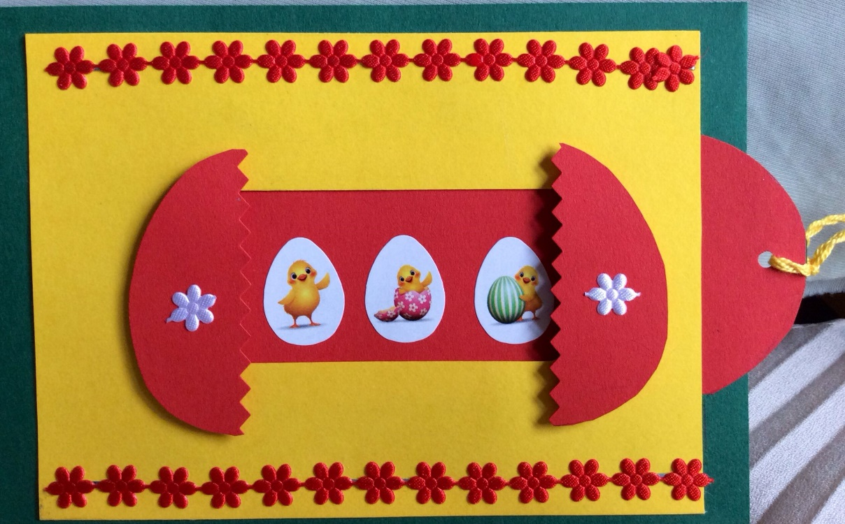

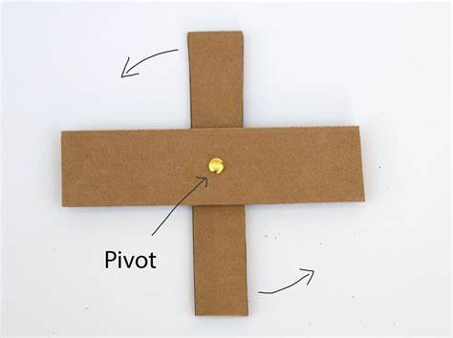
When might a lever be useful?
What could you move using a slider?
How could you improve your card?
Are you a Milecastle Megamind?

