
Year 1 Geography
Polar Regions

Key Vocabulary
Artic | Area around the north (top) of the Earth.
Antarctica | Area around the south (bottom) of the Earth.
Terrain | Land.
Ice bergs | A large floating block of ice.
Glaciers | A sheet of ice that moves slowly.
Inuit | A group of indigenous people who live in the artic.
Explorers | A person or people who investigate a new area.
Expedition | To go on an adventure to find out new things.

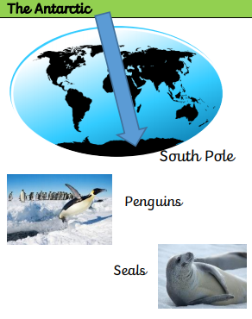
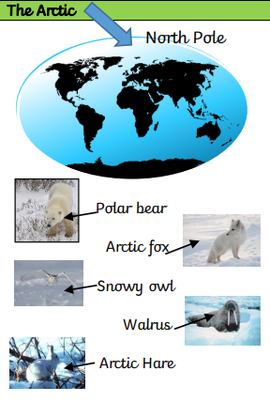

How have animals adapted to living in the cold?
How have humans adapted to living in the Artic?
Are you a Milecastle Megamind?



