
Year 1 History
Homes

Key Vocabulary and Knowledge
Home | The house or flat where a person lives.
Compare and contrast homes over time | What were homes like 100 years ago and 500 years ago?
Rich and poor homes | How were the homes of the rich different from the homes of the poor?
Homes in my local area | What types of homes are in your local area?
Types of homes | Detached, terraced, semi-detached, flats, bungalow.

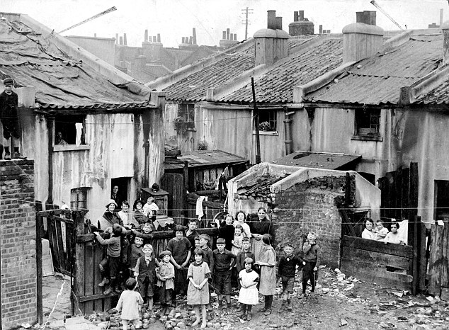
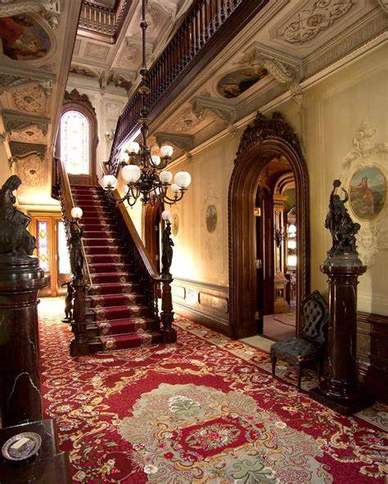
In the past, did all houses have toilets?
Describe a rich Victorian’s house.
In the past, did all houses have electricity?
Are you a Milecastle Megamind?

