
Year 1 Science
Animals

Key Vocabulary
Mammals | Mammals are animals that breathe air, grow hair or fur and feed on their mother’s milk as a baby.
Birds | All birds have a beak, two legs, feathers and wings.
Fish | Live and breathe under water. They have scaly skin, fins to help them swim and they breathe through gills.
Reptiles | All reptiles breathe air and have scales on their skin.
Amphibians | Live in the water as babies and on land as they grow older. They have smooth, slimy skin.
Carnivore | Animals that eat other animals (meat).
Herbivore | Animals that only eat plants and vegetation.
Omnivore | Animals that eat plants and other animals.

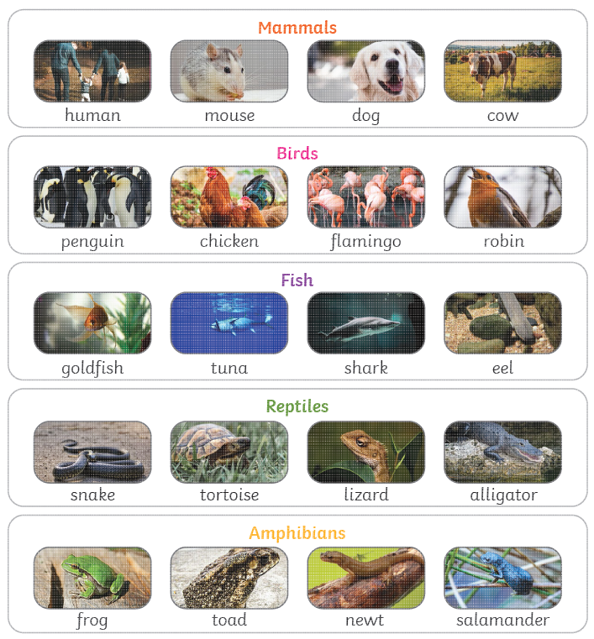

Are you a Milecastle Megamind?

What do animals need in order to survive?
Where can animals live?

