
Maze Explorers

Key Vocabulary
Direction | A course along which someone or something moves.
Challenge | A task or situation that tests someone’s abilities.
Arrow | A mark or sign resembling an arrow, used to show direction or position.
Undo | Cancel or reverse the instruction.
Rewind | Move back several steps or to the start.
Forward | To move in the direction that one is facing or travelling.
Backwards | To move in the opposite direction to which one is facing.
Right turn | To move the object in a clockwise direction.
Left turn | To move the object in an anti-clockwise direction.
Debug | To find and remove errors from computer hardware or software.
Instruction | Information about how something should be done.
Algorithm | A precise, step-by-step set of instructions used to solve a problem or achieve an objective.
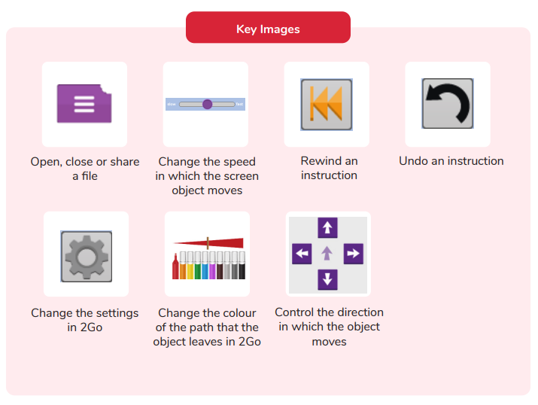

How do you undo a mistake in 2Go?
What is 2Go?
What is a maze?
Are you a Milecastle Megamind?

