
Pictograms

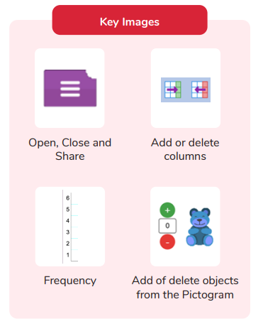
Key Vocabulary
Pictogram | A diagram that uses pictures to represent data.
Data | Facts and statistics collected together that can provide information.
Collate | Collect and combine (text, information or data).

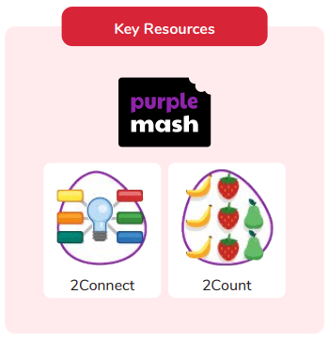
How are pictograms helpful?
What ways do you know to collate information?
Are you a Milecastle Megamind?

