
Year 1
Art - Clay flowers

Key Vocabulary

Exploring and developing ideas | Look closely at different flowers?  How will you start your flower?
Drawing | Make drawings of flowers.
Manipulate | Rolling, kneading, shaping and scoring.  Explore sculpture with a range of malleable media, especially clay.
Construct | Join recycled, natural and man-made materials.  Explore shape and form.
Evaluate | What you and others have done?  What do you think and feel about it?
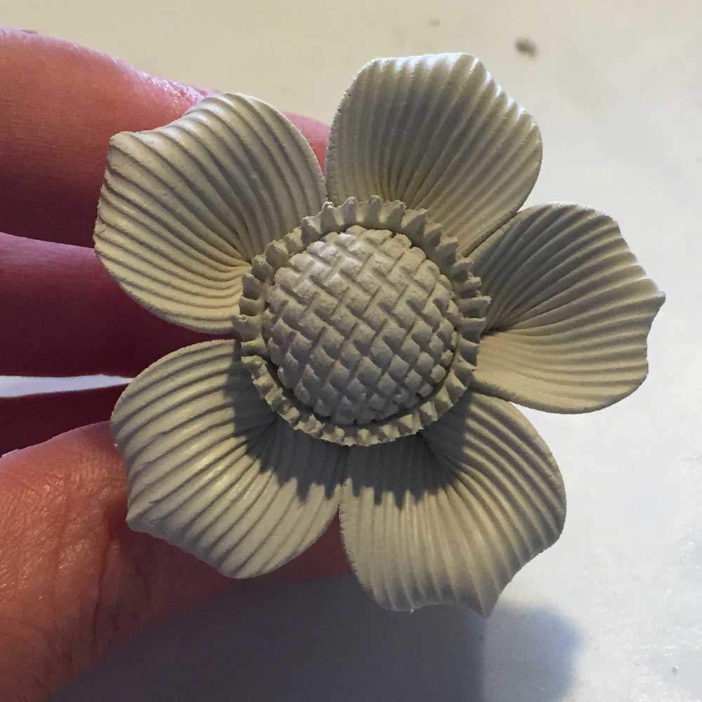
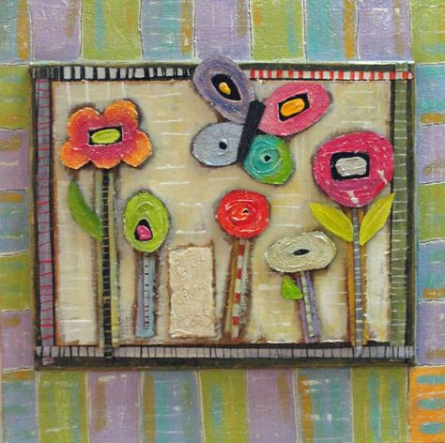
Are you a Milecastle Megamind?

How did you create texture?

What techniques did you use?
Can you explain how to make a clay flower?

