
Year 1
DT – Cooking – What do we need to survive?

Key Vocabulary and skills

Design | Suggest ideas and explain what they are going to do.
Make | Select and use appropriate fruit and vegetables. Use basic food handling, hygienic practices and personal hygiene.
Evaluate | Evaluate their products as they are developed, identifying strengths and possible changes they might make.
Fruit | A fruit is the soft, part of a flowering plant that contains seeds.
Vegetables | Vegetables are parts of plants that are consumed by humans or other animals as food.
Seasonal | The times of year when a food is at its peak, either in terms of harvest or its flavour.
Salad | A salad is a dish of mixed natural raw ingredients. They are usually served at cold.
Smoothie | Blended drinks made from various fruits or vegetables, fruit juices, yogurt.
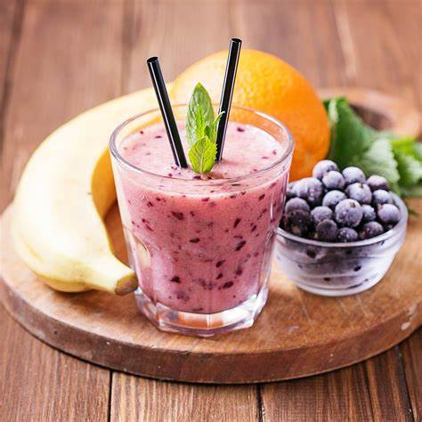
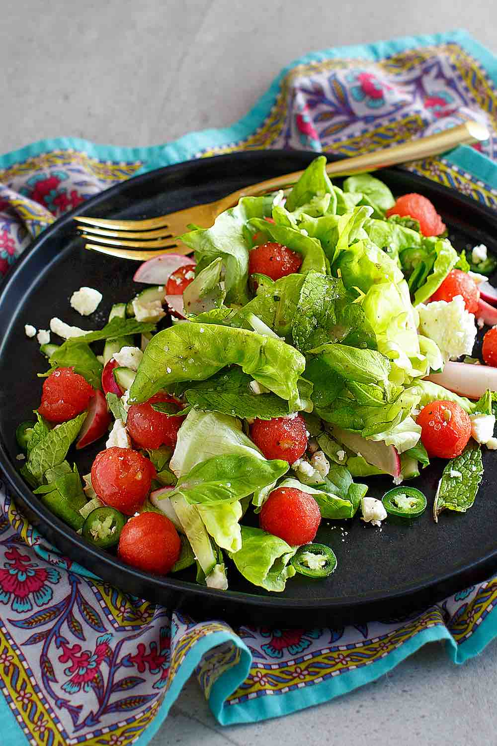
Are you a Milecastle Megamind?

Which fruits and vegetables are in season?
How will you test your product?
What changes would you make?

