
Year 1 History
The Great Fire of London

Key Vocabulary
London | The capital city of England
bakery | A place that makes bread and cakes.
St Paul’s Cathedral | A large church in London.
diary | A book that people write about their lives in.
firebreak | A gap that stops a fire spreading to nearby buildings.
River Thames | The river that runs through the centre of London.
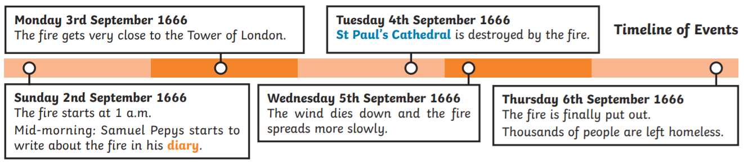

Why did the fire spread so quickly?
How do we know about the events of the fire?
What have we learned as a result of the fire?
Are you a Milecastle Megamind?



