
Year 1 Science
Humans

Key Vocabulary
Senses | Your body has 5 senses.
Sight | Your eyes let you see everything around you.
Hearing | Your ears help you listen to everything around you.
Touch | Your skin helps you feel if something is hot, cold, rough or smooth.
Taste | Your tongue helps you taste. You can tell if something is bitter or sweet.
Smell | You use your nose to smell. You can tell if something smells good or bad.
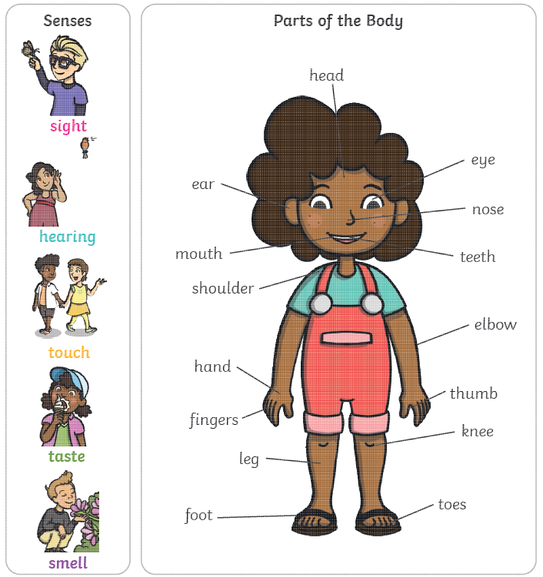

Are you a Milecastle Megamind?

How can we stay healthy?

What type of animal is a human?
What controls our body?

