
Year 1 Science
Plants

Key Vocabulary
Deciduous | Plants that lose their leaves.
Evergreen | Plants that stay green all year round.
Root | Take in water and nutrients from the soil.
Stem | Keeps the plant up straight. It also carries the water and nutrients to other parts of the plants.
Leaf | Catch sunlight to make energy.
Flower | Attracts insects and bees.
Fruit | Holds the plants seeds.
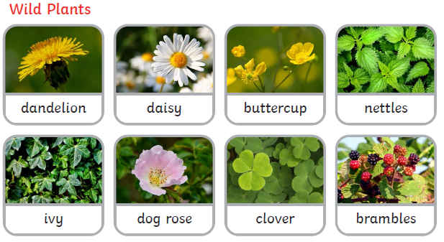

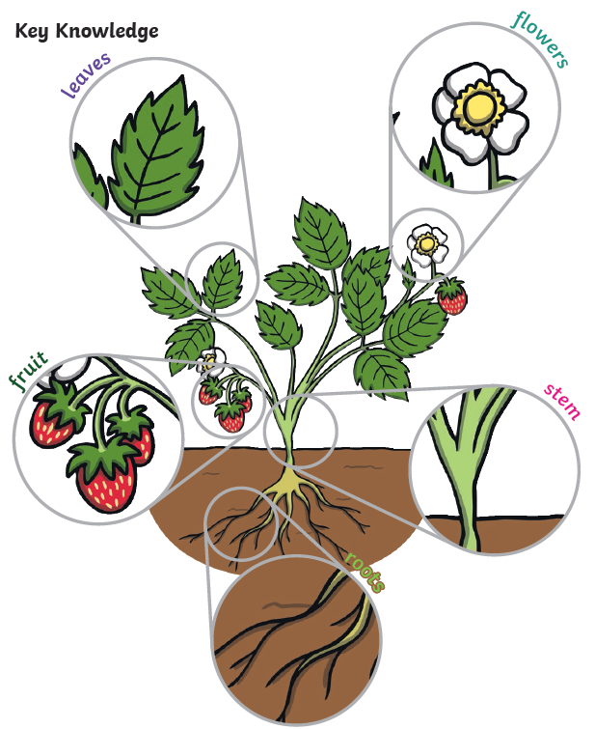

Are you a Milecastle Megamind?

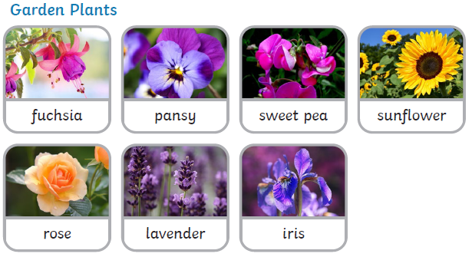

What do plants need in order to stay healthy?

