
Year 1 Science
Seasons

Key Vocabulary
Seasons | There are 4 seasons each year.
Autumn | The weather begins to get colder and the amount of daylight is less. The leaves fall off the trees.
Winter | The weather is much colder. Sometimes it snows. Many trees have bare branches.
Spring | The weather starts to get warmer, leaves begin to grow on the trees and plants begin to flower and animals are born.
Summer | The weather gets hotter and the daytime is long and the nights are short.
Weather | This includes the temperature, wind direction, rain, cloud, snow and sun.
Daylight | When it is light outside.
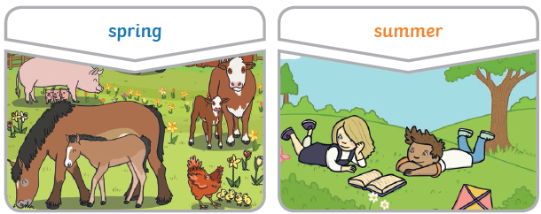
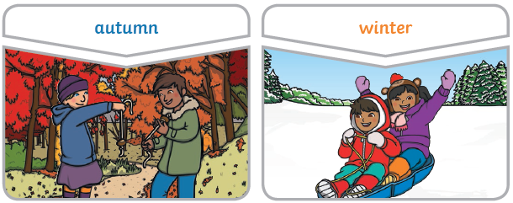
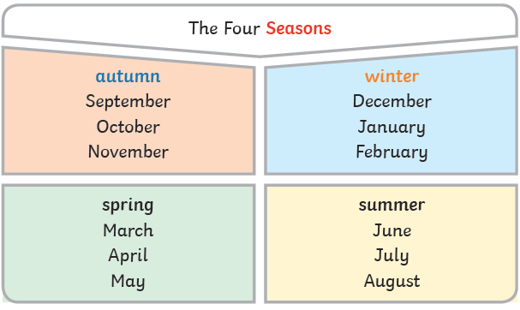
Are you a Milecastle Megamind?

Which month has the longest night and shortest day?



