
Animated Story Books

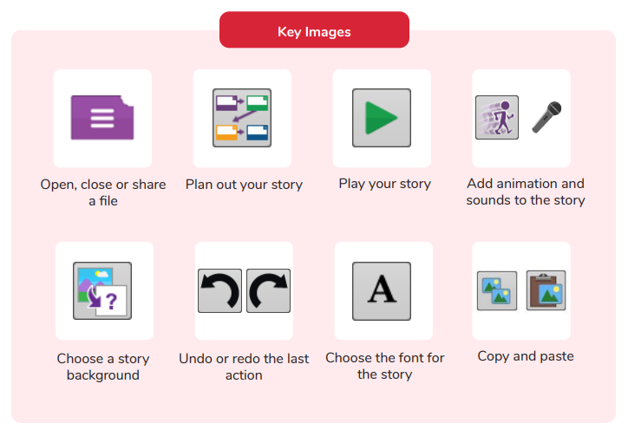
Key Vocabulary

Animation | Process of giving the illusion of movement to drawings and models.
E Book | A book that can be read on the computer or on a tablet.
Font | The style of text used in a piece of writing on the computer or tablet.
File | The style of text used in a piece of writing on the computer or tablet.
Sound Effect | A sound other than speech or music made for use in a play, film or computer file.
Display Board | A way to share your work on Purple Mash.

What is an animated story?
Are you a Milecastle Megamind?

How can I make a story better?

