
Coding

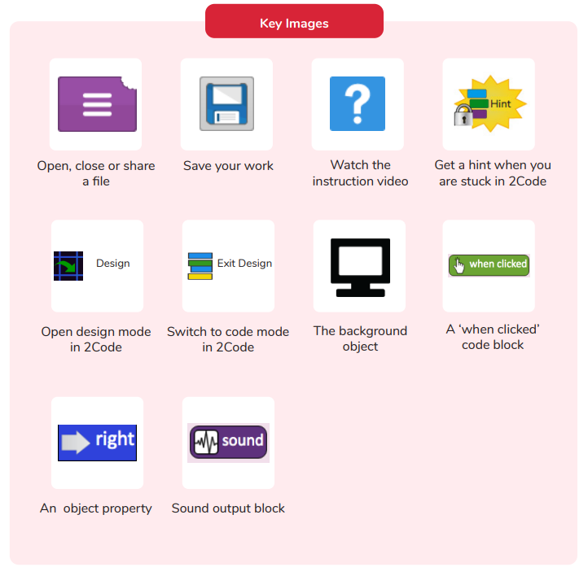
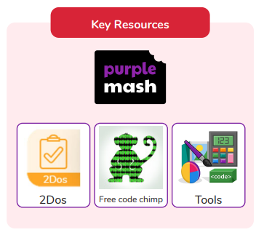

How can you make characters move in a 2Coding program?
What is coding?
Are you a Milecastle Megamind?

Why is it useful to design before coding?

