
Spreadsheets

Key Vocabulary
Arrow keys | Used to move around the cells.
Backspace key | Delete the character before the cursor.
Cursor | A blinking vertical line that indicates position.
Columns | The vertical position of a collection of cells.
Cells | An individual section/box on the spreadsheet.
Clipart | Simple pictures/images/symbols.
Count tool | Counts the number of cells.
Delete key | Use this to remove the contents of a cell.
Image toolbox | Use this to insert images into a cell.
Move cell tool | Drag and drop cells using this tool.
Rows | The horizontal position of a collection of cells.
Spreadsheet | A computer program that represents information in a grid of rows and columns.
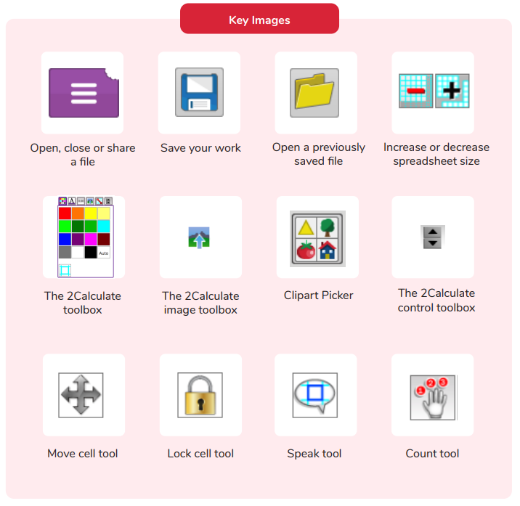

How can you use a spread sheet to add up values?
Are you a Milecastle Megamind?

What does a spread sheet look like?

