
Online Safety

Key Vocabulary
Log in | Using a username and password to access a system.
Avatar | A digital picture to represent someone.
Log out | Leaving a computer system.
Save | Store your work as you create something so that it can be accessed later.
Username | A name that is used by a person to access an online site.
My Work | The place on Purple Mash where your work is stored. Only you and your teachers can access this.
Notification | A picture that lets you know you have a message or have something to look at. This is a bell on Purple Mash.
Password | A series of letters, numbers or characters that is input after the username to allow you access to a site.
Topics | The area on Purple Mash that contains ready made resources.
Tools | The section where the learning apps are.
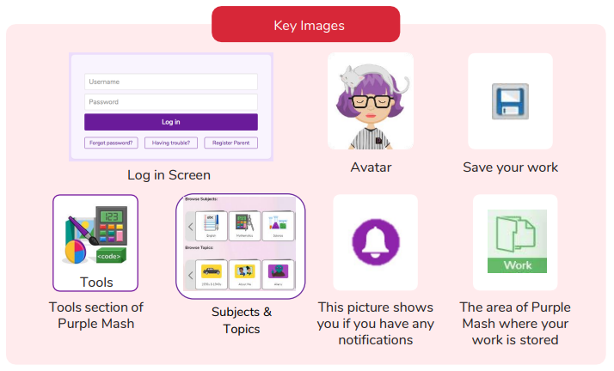

What is a password and why should we keep them safe?
Are you a Milecastle Megamind?

What is a digital avatar?
How do you store your work?

