

Year 2 Computing – Effective Searching
Key Vocabulary
Digital Footprint | The information about a  person that exists on the  Internet as a result of their  online activity
Domain | Part of the Internet owned by an individual, company or organisation.
Internet | A way to send information from one computer to another anywhere in the world using technology such as phones, satellites and radio links.
Network | Connected devices that can send and receive information, voice and video.
Search engine | A program to help you find web pages on the Internet.
Web Adress | Identifying address for a file or web page on the Internet. Also known as URL
Web Page | A single page which can include images, videos and charts.
Web Site | A collection of web pages that belong to one domain.
World Wide Web | The web pages and documents you see when you are browsing online. It is just one part of the Internet

Key Learning
To understand the terminology associated with searching
To gain a better understanding of searching on the internet
To know what to do it if we see something unexpected or upsetting when searching on the internet
To create a leaflet to help someone search for information on the internet


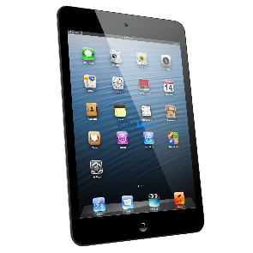





Are you a Milecastle Megamind?

How can I search the internet?
What can I do to keep myself safe while searching online?

