

Year 2 Computing – Questioning
Key Vocabulary
Binary Tree | A simple way of sorting information into two categories
Data | A collection of information, used to help answer questions
Database | A computerised system that makes it easy to search, select and organise information
Field | A single piece of data in a database which makes up a record
Pictogram | A diagram that uses pictures to show data
Record | An item in a database with a variety of information about an entry
Search | Looking for specific information
Sort | Put things together by features they have in common

Key Learning
To learn about data handling tools that can give more information than pictograms
To use yes/no questions to separate information
To construct a binary tree to identify items
To use 2Question (a binary tree database) to answer questions
To use a database to answer more complex search questions
To use a search too to find information
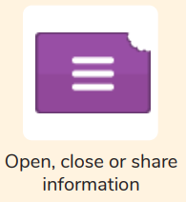

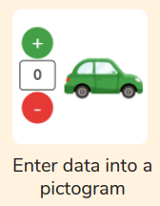

How does a pictogram show information?
Are you a Milecastle Megamind?

How can a database help organise information?
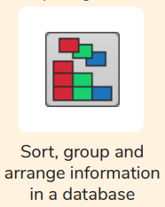
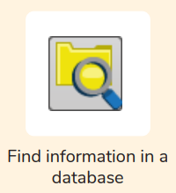
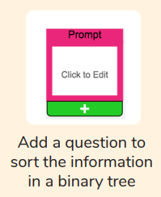
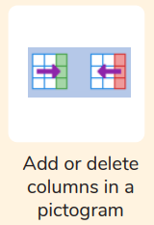
How is information organised in a binary tree?

