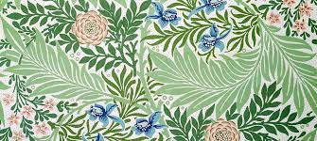
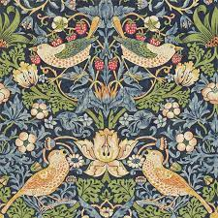

Year 2
Art – William Morris
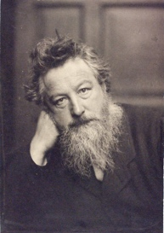
Key Vocabulary
Designer | A person who makes or draws plans for creating something.
Interior designer | A person who is employed to design the decoration for the inside of people's houses.
Block Printing | Printing patterns using engraved wooden blocks.
Repeating pattern | Patterns that repeat themselves over and over again.
Styrofoam | A kind of polystyrene.
Stained glass | Coloured glass used to form decorative or pictorial designs

Key Learning
Printing can be used to create repeating patterns on papers and textiles.
Block Printing is one of the oldest types of printmaking. Traditionally, block printing was mainly used to create intricate patterns and made from wooden blocks printed onto textiles.
Blocks were originally created and printed by hand. It can now be done on large scale machinery.
William Morris was an English architect, furniture and fabric designer, artist and writer.

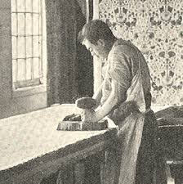
‘Have nothing in your houses that you do not know to be useful or believe to be beautiful.’ William Morris
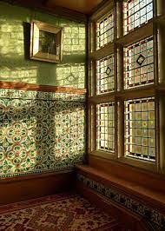

Why did William Morris first begin to create furniture, wallpaper and textiles?

Can you name some of William Morris’ designs?
Can you explain to someone how to make a block for printing using Styrofoam?
Are you a Milecastle Megamind?

