
Year 2 DT – Moving water

Key Vocabulary
waterwheel | A wheel turned by a flow of water against it.
Archimedes screw | A machine that carries water upward from one level to another.
force | A push or a pull.
Hydraulic pressure | Something moved or operated using water power.
syringe | A tube with a plunger.
cylinder | A 3d shape that is round and has a top and bottom in the shape of a circle.

Key Learning
To learn how inventors have solved everyday problems.
Explore products, mechanisms and machinery that are operated using the force of water.
Pushing water through a cylinder can create a force to make something move.
An Archimedes screw can move water to a different level.
Use joining and fixing skills to create a working model of a hydraulic crane?
To encourage creativity and resilience when creating their own invention.
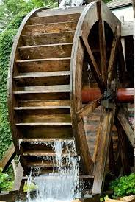
Waterwheel

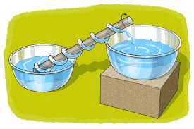
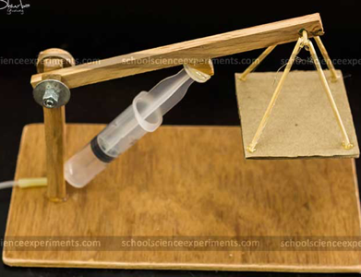
hydraulic crane

How can water be moved upwards?
Why was the hydraulic crane invented?
How can water be used to create a force to move something?
Are you a Milecastle Megamind?

