
Year 2 Geography – Cragside Mapwork
Key Vocabulary
Key | Helps us to understand map symbols
Compass | A tool which shows people which direction they are travelling in
Map Symbol | A picture or sign on a map that represents something else
Route | A way of getting from a start point to a finish point
Atlas | A collection of maps in one book
Physical Feature | A feature that has been formed by nature
Human Feature | A feature that has been made or changed by humans
Aerial View | A view from above. Also known as a bird’s eye view.

Key Learning
To be able to follow a route on a simple map
To identify and use basic map symbols on a map of Cragside
To know the purpose and be able to use a key
To use simple coordinates to locate places on a map of Cragside
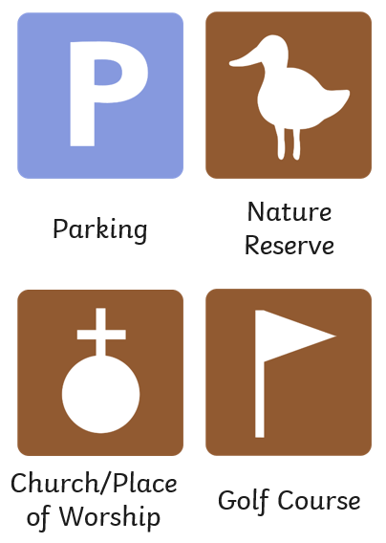

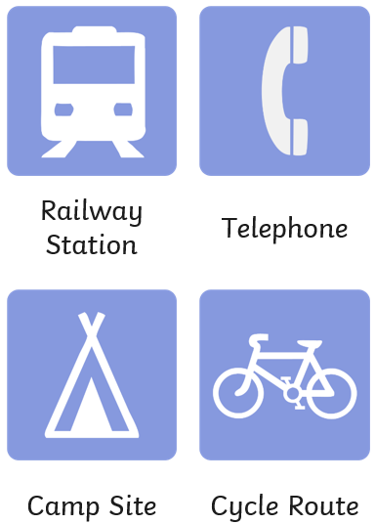
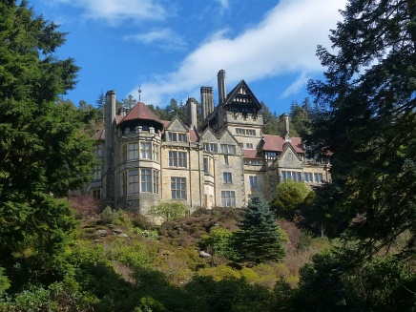
Are you a Milecastle Megamind?

What is the purpose of a key?

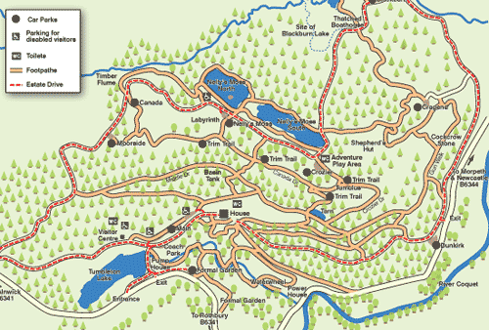
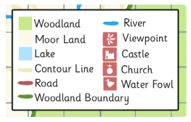
What physical features can you find on a map of Cragside?


