
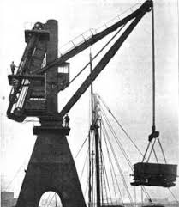
Year 2
History - Inventors

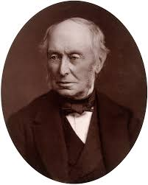
Key Learning
To understand what drives people to invent things.
To understand how people in the past have influenced our lives today.
To recognise change over time and to be able to sequence events or objects in chronological order.
To be able to recognise and establish whether something is old. What evidence can we find of age?
To understand how influential William Armstrong was in our local area and globally. Can the children identify clues in the local area that tell us something about William Armstrong?
To know that John Logie Baird invented the television.
To look at our own televisions and research those of our parents and grandparents. How have they changed over time and why?

To know that Alexander Graham Bell invented the telephone.
To look at our own telephones and methods of communication compared with those of our parents and grandparents. How have they changed over time and why?
Key Vocabulary
invention | A new thing that someone has made.
inventor | A person who makes new inventions that perform some kind of function.
engineer | Someone who designs things that can solve a problem.
hydraulics | Using water to create a force to make things move.
significant | Important.
influence | An effect of one person or thing on another.
communication | To send or receive a message.
image | A picture or reflection of something produced by a device.
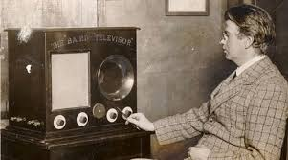
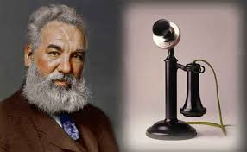
Are you a Milecastle Megamind?

What influence has William Armstrong had in the local area and across the world?
How has television changed over time?
How important was the invention of the telephone?

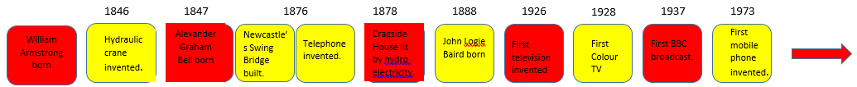
1810
1810

