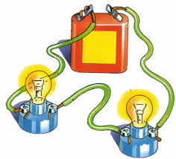

Year 2
SCIENCE - Electricity

Key Vocabulary
electricity | An energy that can be used to make electrical things work.
power station | A place where electricity is produced by burning fuels.
wind turbine | A device that turns wind into electricity.
solar power | Uses solar panels to turn light from the sun into electricity.
water power | Uses the energy from moving water to make electricity.
battery | A container that stores energy until it is needed.
mains electricity | Electricity that travels along large cables into people’s houses.
circuit | A wire runs from a battery to a bulb and back again so that the electricity can flow.
bulb | A device that produces light from electricity.

Key Learning
Identify appliances that run on electricity.
Name and describe different sources of electricity, including: power stations, wind power, solar power and water power. Recognise that a battery stores energy until it is needed.
Explain how to use electricity safely and recognise some dangers associated with electricity.
Understand that a power source and a closed circuit are needed to make an appliance work.

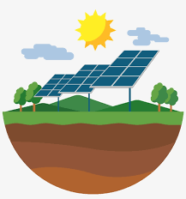
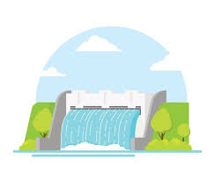
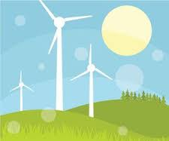
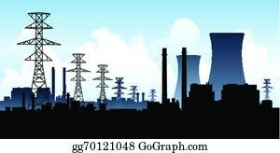
How can we produce electricity differently to help the environment?

Are you a Milecastle Megamind?

In what ways did William Armstrong help to develop the use of electricity?
What can we do in our homes to try to save electricity?

