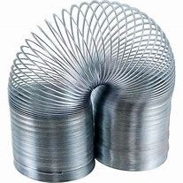
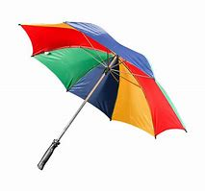

Year 2
SCIENCE – Uses of Everyday Materials

Key Vocabulary
Opaque | A material that you cannot see through.
Transparent | Something that lets light pass through so that you can see through it.
Translucent | Something that lets some light through but you cannot see clearly through it.
Flexible | A material that can be changed in shape.
Rigid | Something that cannot be changed in shape.
Properties | What a material is like or what it can do.
Waterproof | Does not let water pass through it.
Absorbent | Can soak up water.
Suitable | Having the right properties for the purpose.

Key Learning
Objects are made from materials that have suitable properties.
A material can be suitable for different purposes.
An object can be made from different materials.
The shape of some materials can be changed by bending, stretching, squashing and twisting.

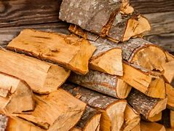
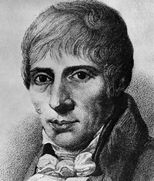
Which scientists do you know about who have made a difference to our lives by inventing new materials?

Are you a Milecastle Megamind?

How could we find out which material would be most suitable for a rain hat?

Can you choose an object and suggest suitable materials it could be made from, explaining why?

