

Year 2 Computing – Creating Pictures
Key Vocabulary
Art | A visual form of creative activity and imagination.
Palette | Within computer graphics, this is the range of colours or shapes available to the user
Fill | Causing an area to become full, in this case, of colour
Pointillism | It was invented mainly by George Seurat and Paul Signac. Pointillist paintings are created by using small dots in different colours to build up the whole picture.
Impressionism | The impressionist movement began in the 1860s. The art gave an ‘impression’ of the scene
Style | A particular way in which something looks or is formed.
Surrealism | Explored the subconscious areas of the mind. The artwork often made little sense as it was usually trying to depict a dream or random thoughts.

Key Learning
To learn the To learn the functions of the 2Paint a
Picture tool
To learn about and recreate the Impressionist style of art (Monet, Degas, Renoir)
To recreate Pointillist art and look at the work of pointillist artists such as Seurat
To learn about the work of Piet Mondrian and recreate the style using the lines template
To learn about the work of William Morris and recreate the style using the patterns template
To explore surrealism and eCollage
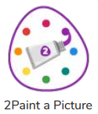



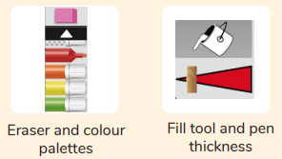
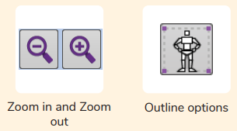

Are you a Milecastle Megamind?

What are the main features of Pointillism?
What are the benefits of creating a piece of art using technology?

