

Year 2 Computing – Making Music
Key Vocabulary
Beat | A rhythmic unit in music
Tune | Musical notes joined together to make a melody
Speed | The number of beats per minute (bpm) played in the music.
Compose | To create a piece of music
Sound effect | A sound other than speech or music
Tempo | The speed at which the music plays
Note | A single tone in music
Soundtrack | A recording of the musical accompaniment of a film or tv programme
Volume | How loud or quiet the music is

Key Learning
To make music digitally using 2Sequence.
To explore, edit and combine sounds using 2Sequence
To edit and refine composed music
To think about how music can be used to express feelings and create tunes which depict feelings
To upload a sound from a bank of sounds into the Sounds section
To record and upload environmental sounds into Purple Mash
To use these sounds to create tunes in 2Sequence
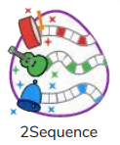



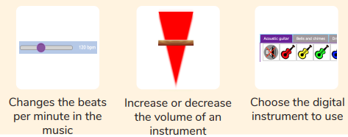
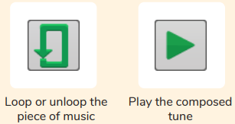

Are you a Milecastle Megamind?

What is meant by digital music?
How can I change how my music sounds?

