
Year 2 Computing – Presenting Ideas
Key Vocabulary
E- Book | An electronic version of a printed book that can be read on a computer or a specifically designed handheld device
Fact File | A document containing all the important information about one subject
Fiction | A book or story that is written about imaginary characters and events and not based on real people or places
Mind Map | A tool for organising and representing knowledge. They form a web of ideas which are all interconnected
Node | A way to represent a concept or idea using text and/or images
Non-Fiction | Writing that is about real people or events rather than stories that have been made up
Presentation | A way of displaying information about a subject to an audience.
Non-Fiction | A book or story that is written about imaginary characters and events and not based on real people or places

Key Learning
To explore how a story can be presented in different ways
To make a quiz about a story or class topic
To make a fact file on a non-fiction topic
To make a presentation to the class


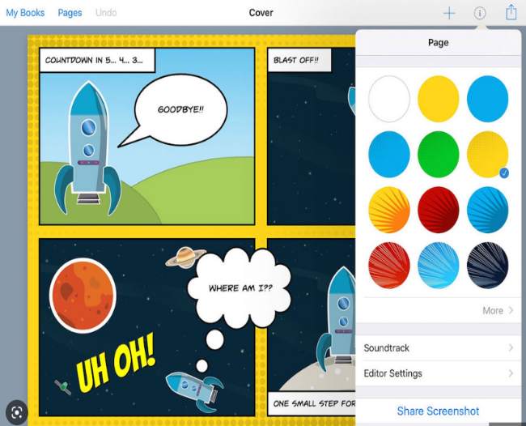
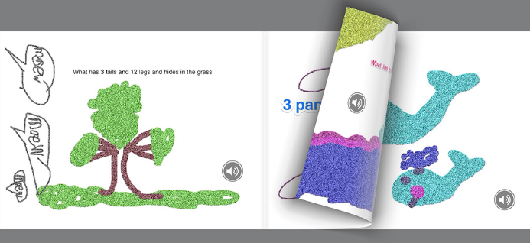

Are you a Milecastle Megamind?

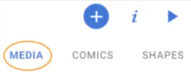
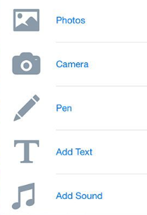
Why should I plan out my E-Book?

How can we present our information in an attractive and clear way?

