
YEAR 3
ART

Key Vocabulary
Media/medium | The materials and tools used by an artist to create a piece of art.
Technique | The way an artist uses tools and materials to create a piece of art.
Tint | When you add white to a colour to make it lighter.
Highlight | The bright or reflective area on an object or piece of art.
Shadow/shade | The darker areas within a piece of art or object
Key Learning
Explore Hokusai’s artwork ‘The Great Wave’.
Use a range of brushes and painting techniques to recreate ‘The Great Wave’.
Create a clay sculpture of an ammonite.
Create a 3D model volcano using Papier-mâché
Look at ways of changing fabrics using dyes – holiday t-shirt
Use different media to achieve variations in line, texture, tone colour, shape and pattern.

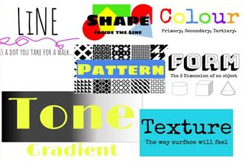
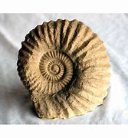
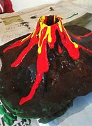
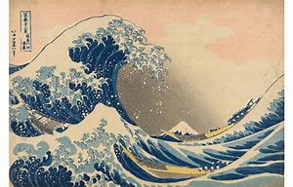

What effects can I create using different brushes on paint?
What is tie-dye and can I create similar patterns with pencil?
How do you think the artist created this image?
Are you a Milecastle Megamind?

