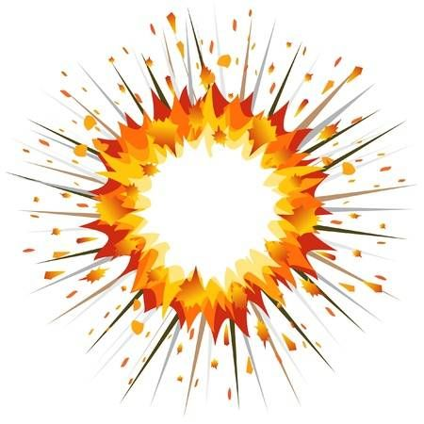

YEAR 3
GEOGRAPHY – Extreme Earth

Key Learning
Name the layers that make up the Earth.
Name the key parts of a volcano.
Show where most volcanoes are found.
Explain how to stay safe during an earthquake
Describe a tsunami and the damage it can cause
Explain how tornadoes form
Describe how scientists collect data about storms
Key Vocabulary
Erupt | When a volcano becomes active it ejects lava, ash and gasses
Magma | Hot liquid rock located under the Earth’s surface
Tectonic Plates | Huge slabs of solid rock that connect together on the Earth’s surface
Tsunami | A long, high sea wave caused by an earthquake or other disturbance
Dormant | Volcanoes that have not erupted for a long time but may erupt again.
Extinct | Volcanoes that are not expected to erupt in the future
Active | Volcanoes that have recently erupted and are likely to erupt again
Magnitude | The size and power of an earthquake
Richter | A scale of numbers used to tell the power (magnitude) of an earthquake
Tornado | A swirling funnel of air that forms when warm air rises from near the ground

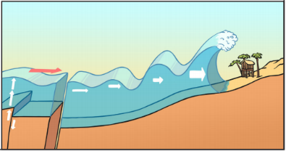
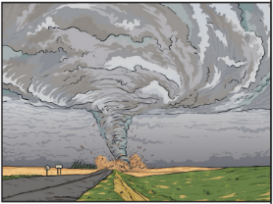
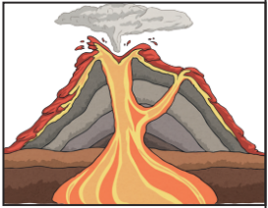

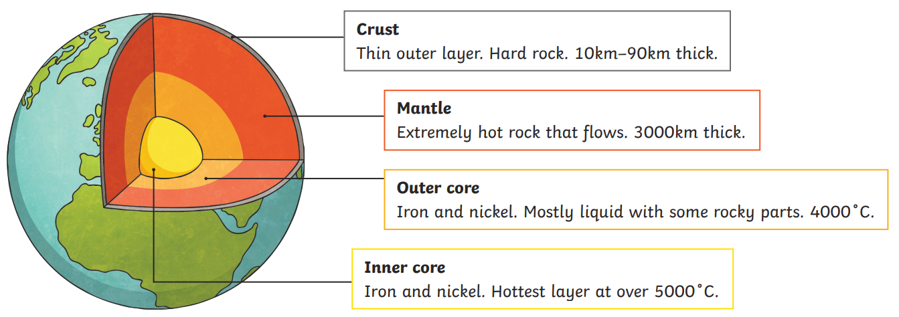
Tsunami
Tornado
Volcano

Can you describe what is under our feet?
Are you a Milecastle Megamind?

What happens during a volcanic eruption?

