
Year 3
Science – Plants

Key Vocabulary
carpel | The female parts of the flower. Made up of the stigma, style and ovary.
fertilisation | When the male and female parts of the flower have mixed in order to make seeds for new plants.
flowers | These make seeds to grow into new plants.
germination | When a seed starts to grow.
leaves | These make food for the plant using sunlight and carbon dioxide from the air.
nutrients | These substances are needed by living things to grow and survive. Plants get nutrients from the soil and also make their own food in their leaves.
petal | The brightly coloured part of the flower that attracts insects to pollinate the plant.
pollination | When pollen is moved from the male anther of a flower to the female stigma.
roots | These anchor the plant into the ground and absorb water and nutrients from the soil.
seed dispersal | A method of moving the seeds away from the parent plant so that the seeds have the best chance of survival.
stamen | The male parts of the flower. The stamen is made up of the anther and the filament.
stem | This holds the plant up and carries water and nutrients from the soil to the leaves.
Key Learning
Identify and describe the functions of different parts of flowering plants: roots, stem, leaves and flowers.
Explore the requirements of plants for life and growth and how they vary from plant to plant.
Investigate the way in which water is transported within plants.
Explore the parts that flowers play in the life cycle of flowering plants, including pollination, seed formation and seed dispersal.
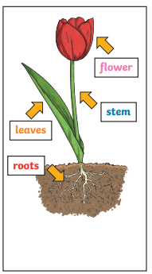

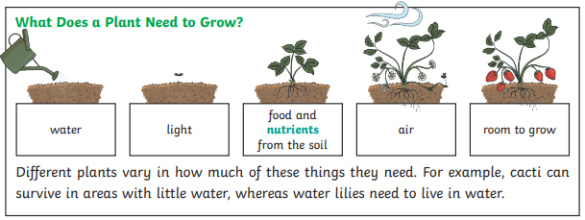

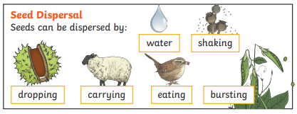
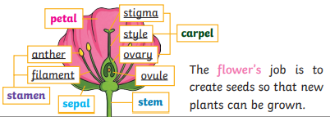

Are you a Milecastle Megamind?

What happens to celery when it is left in a glass of coloured water?
How can you tell if something is a plant?
What colour flowers do pollinating insects prefer?

