
Year 3
Science – Rocks

Key Vocabulary
decay | To rot or decompose
erosion | When water, wind or ice wears away land.
fossil | The preserved remains of a dead organism.
fossilisation | The process by which fossils are made.
geologist | A person who studies rocks.
igneous rock | Rock that has been formed from magma or lava.
impermeable | Does not allow liquid to pass through.
lava | Molten rock that comes out of the grown.
magma | Molten rock that remains underground.
metamorphic rock | Rock that started out as igneous or sedimentary rock but changed due to being exposed to extreme heat or pressure.
permeable | Allows liquid to pass through.
rock | Any naturally occurring solid mineral material.
sedimentary rock | Rock that has been formed by layers of sediment being pressed down hard and sticking together. You can see the layers of sediment in the rock.
soil | Made up of pieces of rock, minerals, decaying plant material, microbes and water.
Key Learning
Compare and group together different kinds of rocks on the basis of their appearance and simple physical properties.
Describe how fossils are formed when things that have lived are trapped within rock.
Recognise that soils are made from rocks and organic matter.
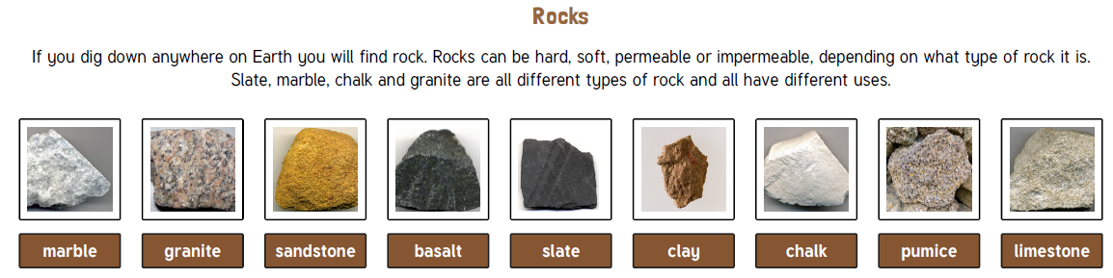

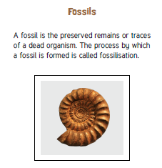
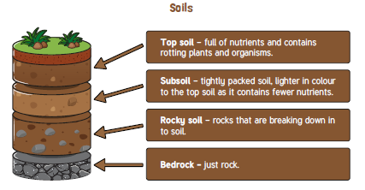
Are you a Milecastle Megamind?

Who was Mary Anning and what did she discover?
Is there a pattern in where we find volcanoes on planet Earth?

