
ICT – Touch Typing and email

Key Vocabulary
Posture | The correct way to sit at the computer.
Keys | Buttons that are pressed on a computer keyboard or typewriter. These can be described by their position; bottom row, top row and home row (middle row).
Space bar | The bar at the bottom of the keyboard.
Typing | The action or skill of writing something by means of a typewriter or in this case a computer
Address book | A list of people who you regularly send an email to.
CC | A way of sending a copy of your email to other people so they can see the information in it.
Email (Electronic Mail) | An Internet service that allows people who have an email address to send and receive instant electronic letters.
Personal Information | Identifying information about yourself such as your name, address and telephone number.
Attachment | A file, which could be a piece of work or a picture, that is sent with the email.
Communication | The sharing or exchanging of information by speaking, writing, or using some other medium such as email.
Inbox | The folder where new emails go into when they are received.
Save to draft | Allows you to compose an email and save it to draft folder to review later before sending.
BCC Blind Carbon Copy | A way of privately sending a copy of your email to other people so they can see the information in it, without the recipient knowing.
Trusted Contact | A person who you know and trust, making an email from them safe to open.
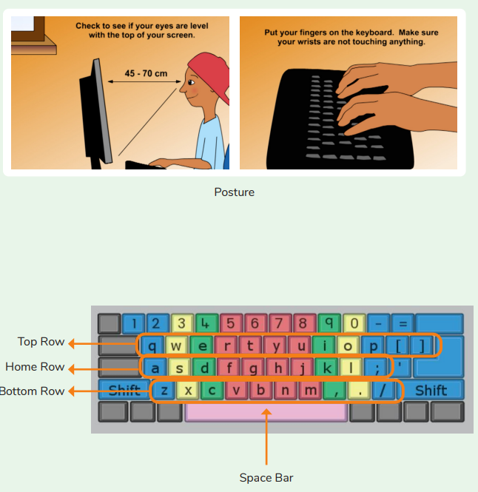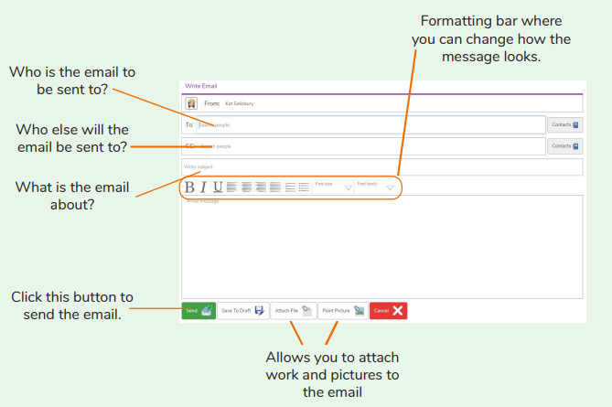
Why should I have a good posture at the computer?
Are you a Milecastle Megamind?

