
Year 3
Art – Ancient Greece


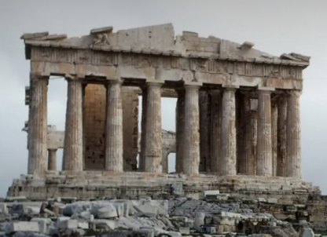
Key Vocabulary
column | A supporting pillar.
Corinthian column | The most decorative of columns. It has thin grooves running up the sides which is decorated at the top with leaves and scrolls.
Doric column | The earliest style and used by the Greeks for most of their buildings and temples. The style features heavy columns, a saucer shaped capital on top and no base.
Ionic column | Stands on a base with a scroll like ornament at the top.
legacy | Something lasting to remember a person or event for future generations,
patterns | Repetition of elements of a piece of artwork.
perspective | The angle from which you are looking at something.
shading | Drawn marks to show areas of light and dark.
terracotta | A brownish-reddish clay.
texture | The way a piece of art looks and feels.
Key Learning
In ancient Greece there were two main types of plays: comedies and tragedies. The ancient Greek comedy and tragedy masks have today become a symbol of the theatre. We can use cutting and layering techniques to create a mask with a clear expression.
Study the colours and images the Greeks used to decorate their pottery. Create different effects with chalk pastels to design your own Greek vase.
The ancient Greeks were famous for their impressive buildings. Look at the Parthenon in detail and study the three main types of columns – Ionic, Corinthian and Doric. Use pencils to create sketches and different effects.
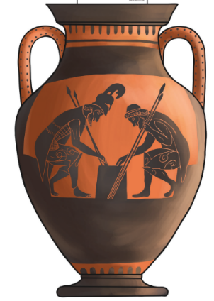
What is the Parthenon built from?
Has ancient Greek architecture inspired buildings around us today?
Are you a Milecastle Megamind?

How can we learn about the Ancient Greeks from art?


