


Year 3
Design Technology – Mechanisms: Linkages and levers
Key Learning
Mechanical systems such as levers and linkages or pneumatic systems can create movement.
Experiment with different linkages and levers.
Use a design criteria to create a final design idea. Discuss ideas together and give reasons for choices.
Create a prototype to test the process.
Use the annotated sketches and prototypes to help create the final product.
Check that the product meets the design criteria and has achieved its purpose.
Key Vocabulary
Design brief | A description of a product to be designed. It states how a product will function to meet the needs of the user.
Fixed pivot | A paper fastener that joins card strips to the backing card.
Linear motion | Moving in a straight line e.g., paper trimmer
Loose pivot | A paper fastener that joins card strips together.
Mechanical systems | Something that uses related components which act together to create a movement.
Mechanism | A device used to create movement in a product.
Motion | Movement from one place to another.
Oscillating motion | Swinging from side to side in an arc e.g., a pendulum in a clock.
Pivot | To turn on a central point.
Reciprocating motion | Moving forwards and backwards in a straight line e.g., cutting with a saw
Rotary motion | Turning around in a circle e.g., a wheel

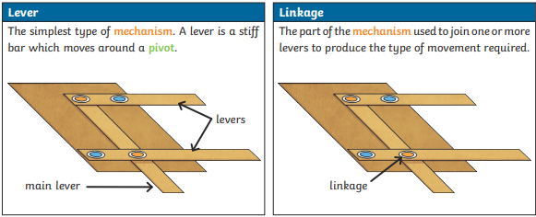
Are you a Milecastle Megamind?

Why is it important to produce a prototype?
What is a mechanical system?
Can you explain the difference between a lever and linkage?

