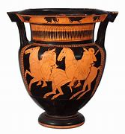

YEAR 3
HISTORY – Ancient Greece

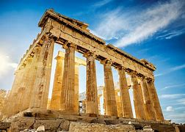
Key Vocabulary
AD and BC | ‘Anno Domini’ and ‘Before Christ’ – time measurements.
Alexander the Great | King of Ancient Greece, explorer and conqueror.
ancient | Something from a very long time ago.
Athens | Greece’s capital city.
city states | Small areas that ancient Greece was divided into, each with their own governments, laws and army.
civilisation | A human society with well-developed rules and government often where technology and the arts are considered important.
country | A nation with its own government.
democracy | When people can vote for their own agendas.
empire | A group of states or countries ruled by one person.
myth | A story from ancient times about something that happened long ago that some people believed to be true.
Olympics | Competitive games.
Politics | Debate around who will rule/govern a country.
Key Learning
In Ancient Greece, Kings ruled and were able to make many important decisions.
Alexander the Great ruled Greece in 336 BC and was a very influential man due to invading lots of other countries and spreading Greek culture.
The Peloponnesian War happened during 431 BC – 404 BC and the Romans conquered Greece in 146 BC.
Ancient Greek inventions have helped us in our lives today, including their contributions to maths, English and science.
The Olympic Games was first held in ancient Greece in 776 BC.
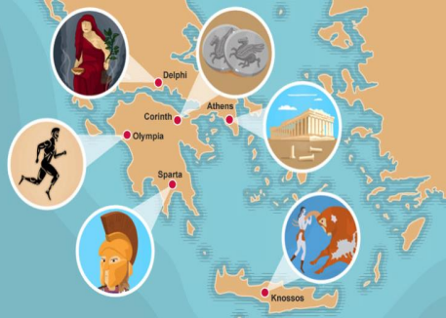
Are you a Milecastle Megamind?

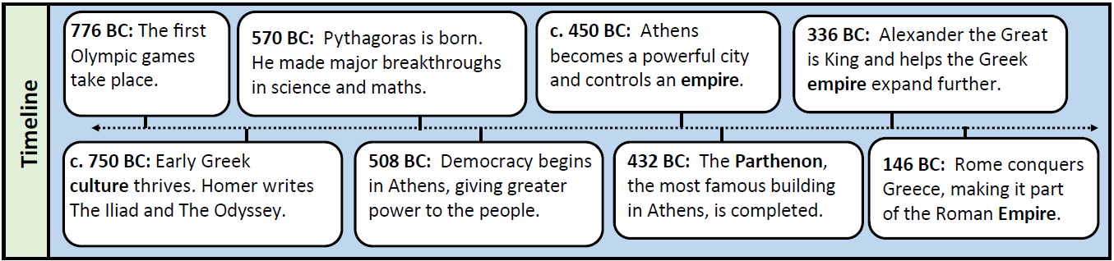
Who were the Spartans?
In which city-state did the Olympic Games begin in?
Who gave the ‘Greeks’ their name?

