
Year 3
Science – Forces & Magnets

Key Vocabulary
attract | To pull towards.
contact | When objects touch.
force | A push or pull that acts upon an object that can cause it to move, change shape or change direction.
friction | A force that acts between two surfaces or objects that are moving, or trying to move, across each other.
magnet | An object which produces a magnetic force that pulls certain objects towards it.
magnetic | Objects which are attracted to a magnet are magnetic. Objects containing iron, nickel or cobalt metals are magnetic.
magnetic field | The area around a magnet where there is a magnetic force which will pull magnetic objects towards the magnet.
poles | North and south poles are found at different ends of a magnet.
repel | To push away.
Key Learning
Compare how things move on different surfaces.
Notice that some forces need contact between 2 objects, but magnetic forces can act at a distance.
Observe how magnets attract or repel each other and attract some materials and not others.
Investigate which materials are magnetic.
Describe magnets as having 2 poles.
Predict whether 2 magnets will attract or repel each other.
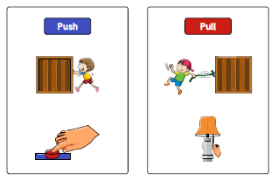

Magnetic field
Magnetic poles

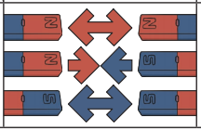
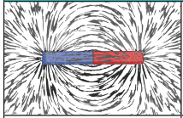

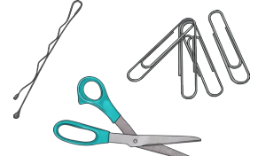
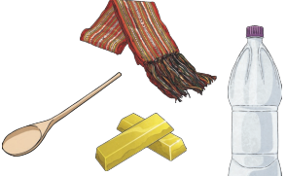
Are you a Milecastle Megamind?

Does the size and shape of a magnet affect how strong it is?
How does a compass work?
Non-magnetic X
Magnetic

