
Year 3
Science – Light

Key Vocabulary
light | A form of energy that travels in a wave from a source.
light source | An object that makes its own light.
dark | Dark is the absence of light.
reflection | The process where light hits the surface of an object and bounces back into our eyes.
reflect | To bounce off.
reflective | A word to describe something which reflects light well.
ray | Waves of light are called light rays. They can also be called beams.
shadow | An area of darkness where light has been blocked.
opaque | Describe objects which do not let any light pass through them.
translucent | Describes objects that let some light through, but scatter the light so we can’t see through them properly.
transparent | Describes objects that let light travel through them easily, meaning that you can see through the object.
Key Learning
Recognise that we need light in order to see things and that dark is the absence of light.
Notice that light is reflected from surfaces.
Recognise that light from the sun can be dangerous.
Recognise that shadows are formed when the light from a light source is blocked by a solid object.
Find patterns in the way that the size of shadows change.
The sun is a source of light. The moon is not a source of light, we can see it because it reflects light from the sun.

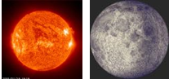

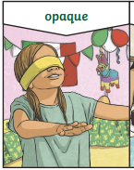
S.O.S!
Source Object Shadow
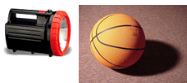
A shadow is formed behind an object when it blocks the light.

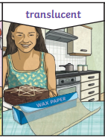
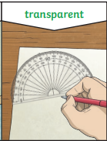
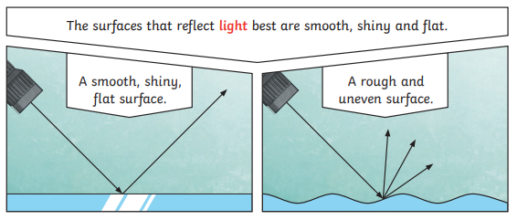
Are you a Milecastle Megamind?

How does the Sun make light?
Is the Sun the same brightness all day?

