
ICT – Simulation and Graphing

Key Vocabulary
Analysis | A detailed examination of something.
Modelling | The act of representing something, often on a smaller scale.
Simulation | A program that models a real-life situation. They let you try out things that would be too difficult or dangerous to do in real life.
Evaluation | To judge the effectiveness of something. Is it worthwhile doing?
Decision | The act or result of making a choice after careful thought.
Axis | A fixed reference line for measuring coordinates.
Data | The collection of information to help decision making.
Row | Horizontal divisions of a piece of work.
Chart | A diagram showing data.
Graph | These include bar and line graphs to represent the data in the chart.
Sorting | Organising data using a rule.
Column | Vertical divisions of a piece of work.
Investigation | A formal inquiry – asking a question.
Tally chart | A way of recording data by counting in fives.
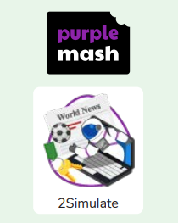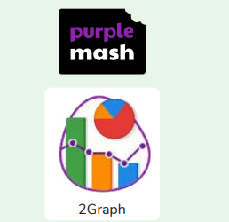
What is a computer simulation? When might you use one? What data would you collect?
Are you a Milecastle Megamind?

