
Year 4
Design and Technology – Shell, solid and combination structures

Key Vocabulary
2D | Two-dimensional
3D | Three-dimensional
net | A 2D shape which can be folded to produce a 3D shape
design specification | A series of specific points that a product needs to meet
annotated diagram | Labelled drawing
modify | To alter or change a design
masking tape | Low tack adhesive tape
frame structure | A structure made by joining together a number of pieces of wood, metal, card or plastic
shell structure | A hollow structure with a thin outer layer
strengthen | To make or become stronger
triangulation | The use of triangular shapes to strengthen a structure
layering | The use of several layers to stiffen sheet materials
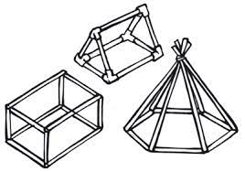
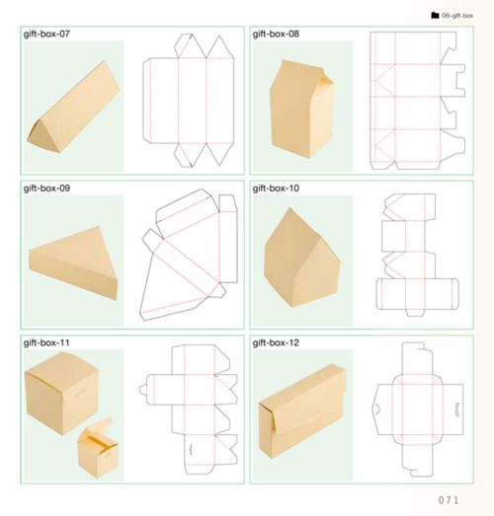

Key Learning
Know that triangulation can add strength to a frame structure.

Know that cylinders can be used as strong components for building frameworks.

Know that corrugating, ribbing and laminating are techniques which strengthen materials.
Make annotated diagrams.

Know that a shell structure may be used to protect things.

Use finishing techniques successfully.
Design, make and evaluate a gift box.

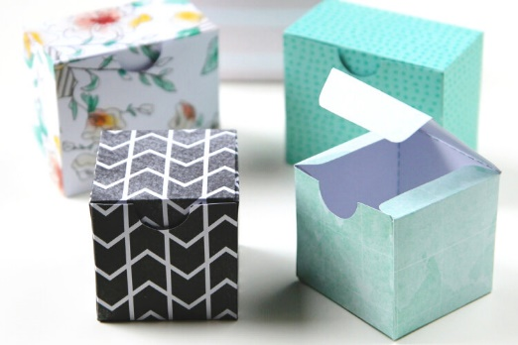

How can structures be strengthened?

How can you make a freestanding structure more stable?

Are you a Milecastle Megamind?

Can you describe different joining techniques?

Where is the source of the River Tyne?

How are rivers used?

