
Year 4
Science – Animals including humans

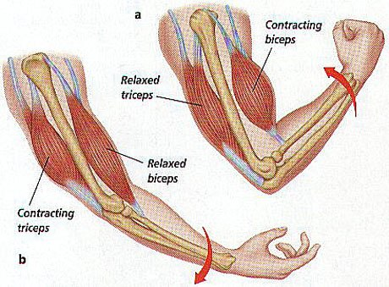
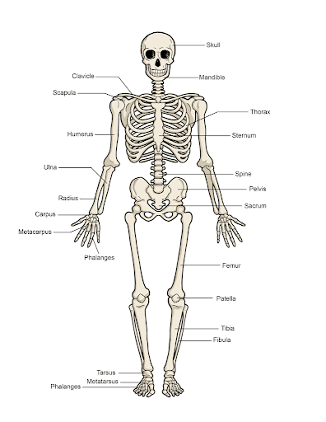

Key Vocabulary
skeleton | The framework of bones in an animal’s body
vertebrate | An animal with a backbone
invertebrate | An animal without a backbone
muscles | Soft tissues in the body that contract and relax to cause movement
tendons | Cords that join muscles to bones
joints | Areas where two or more bones are fitted together
diet | The kinds of food that a person or animal eats.
nutrients | Substances that living things need to stay alive and healthy
energy | Strength to be able to move and grow
saturated fats | Types of fats, considered to be less healthy, that should only be eaten in small amounts
unsaturated fats | Fats that give you energy, vitamins and minerals
Key Learning
The skeleton has three main functions:
- To protect organs inside the body
- To allow movement
- To support the body
Vertebrates have endoskeletons – a skeleton on the inside of the body that supports and protects it.
Invertebrates have either an exoskeleton (a skeleton on the outside of the body that supports and protects it) or a hydrostatic skeleton (a skeleton made up of a fluid-filled compartment in the body called a coelom).
Skeletal muscles work in pairs to move the bones they are attached to by taking turns to contract (get shorter) and relax (get longer).
Living things need food to grow and to be strong.
Plants can make their own food but animals cannot.
To stay healthy, humans need to exercise, eat a healthy diet and be hygienic.
Animals, including humans, need food, water and oxygen to stay alive.
The main nutrients are: carbohydrates, protein, fibre, fats, vitamins, minerals and water.
To know examples of where the different nutrients can be found and their function.
Are you a Milecastle Megamind?

Can you name some of the bones in the human skeleton?
Can you name the different nutrients and give examples of each?
Can you explain the difference between vertebrates and invertebrates?

Where is the source of the River Tyne?

How are rivers used?

