
Year 4 Computing
Animation

Key Vocabulary
animation | The process of adding movement to still objects.
FPS (frames per second) | The number of frames played per second.
frame | A single image in an animation.
onion skinning | A process where the shadow image of the previous frame is present to help you line up the objects of the animation correctly.
pause | To temporarily stop the animation.
stop motion | A technique whereby the camera is repeatedly stopped and started, for example, to give animated figures the impression of movement.
Key Learning
To discuss what makes a good animated film or cartoon.

To learn how animations are created by hand.

To find out how animation can be created in a similar way using the computer.

To learn about onion skinning in animation.

To add backgrounds and sounds to animations.
To be introduced to ‘stop motion’ animation.
To share animation on the class display board and by blogging.

Are you a Milecastle Megamind?

What is an animation?

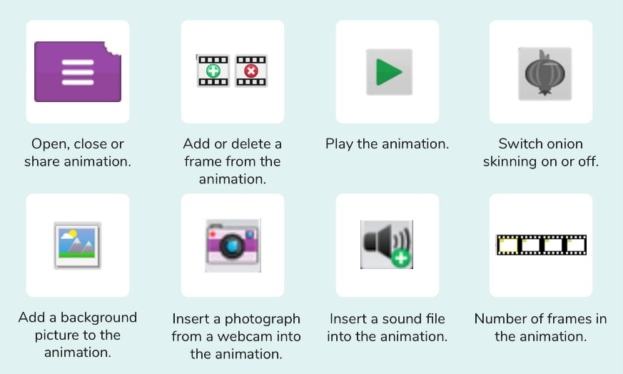
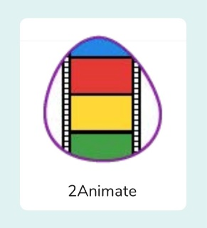
What is meant by stop motion animation?
What is meant by onion skinning?

