
Year 4 Computing
LOGO

Key Vocabulary
debugging | The process of identifying and removing errors from computer hardware or software.
grid | The template around which the 2Logo turtle moves.
LOGO | A text-based coding language used to control an on screen turtle to create mathematical patterns.
LOGO commands (e.g. FD, BK, RT, LT) | A list of commands inputted into 2Logo to move the turtle around the screen.
multi line mode | Type several lines of commands in the text area.
pen down | Lowers the screen pen so the 2Logo turtle draws a line on the screen.
pen up | Raises the screen pen so the 2Logo turtle does not draw on the screen.
prediction | When you say what is going to happen when you run the instructions.
procedure | Pieces of Logo text with a procedure name that can be run by calling them by name. Saves time if you want to print to screen lots of the same shape.
repeat | A set of instructions that is run a specified number of times.
run speed | The speed at which the 2Logo turtle moves around the screen.
SETPC | Set pen colour to a given colour.
SETPS | Set the thickness of the pen’s line.
Key Learning
To learn the structure of the coding language of Logo.

To input simple instructions in Logo.

Using 2Logo to create letter shapes.

To use the Repeat function in Logo to create shapes.

To use and build procedures in Logo.

Are you a Milecastle Megamind?

Can you explain what Logo is?

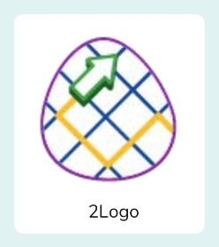
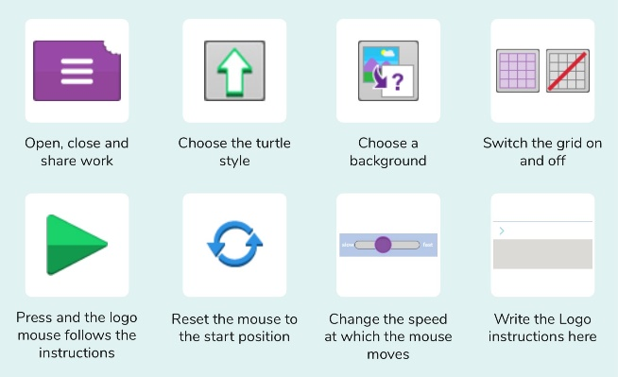
Can you make predictions before you run the instructions?

Can you use 2Logo to write your name?

