
Year 4
Geography - Rivers

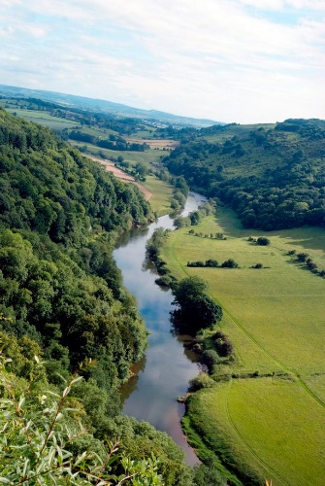
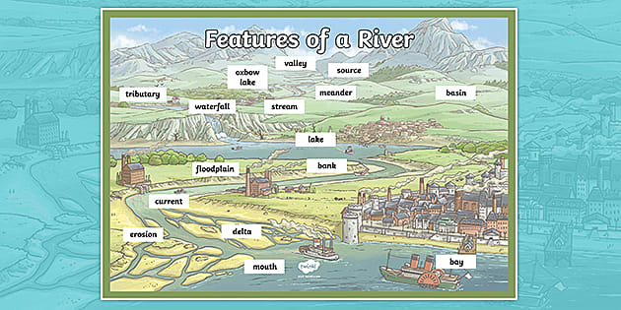
Key Vocabulary
source | The place where a river begins.
mouth | The point where a river joins the sea or a lake.
channel | The course in the ground that a river or water flows through.
tributaries | Streams or small rivers that join up with another river.
confluence | The place where two rivers meet
waterfall | Where water flows over a cliff or very steep drop in the river’s bed.
meander | A bend in the river.
oxbow lake | Where two meanders merge together through erosion.
erosion | Rocks and other river materials are picked up by the water and moved to another place along the river.
dam | A barrier built to hold back water.
Key Learning
The source of most rivers is on high ground or in the mountains.
In the upper course of a river, the water flows quickly and the channel has steep sides and runs through valleys. Features of the upper course include waterfalls and rapids.
In the middle course of a river, the water is fast flowing which causes erosion, making the river deeper and wider. Features of the middle course include meanders.
In the lower course of a river, the water flows with less force due to being on flat land. The river deposits the eroded material that it has carried. Features of the lower course include floodplains, deltas and estuaries.
Know examples of major UK rivers.
Know examples of major world rivers.
Know examples of how rivers are used.
Know about the risk of flooding.
Are you a Milecastle Megamind?

How are rivers important in our lives?
Can you describe the journey of a river?
Can you name some major rivers of the UK and the world?

Where is the source of the River Tyne?

How are rivers used?

