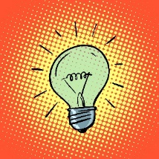

Year 4
Science – Electricity

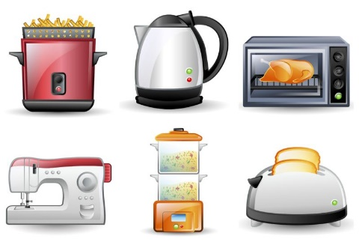
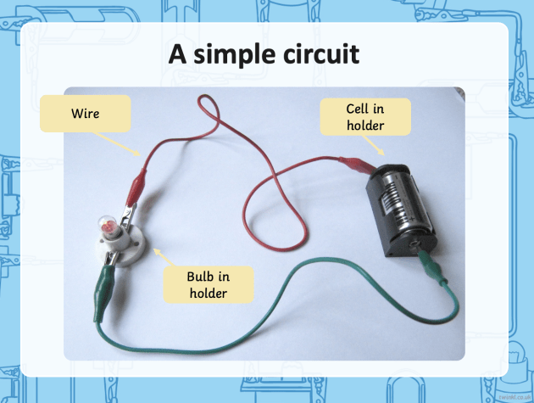
Key Vocabulary
electricity | The flow of an electric current through a material e.g. from a power source through wires to an appliance.
circuit | A pathway that electricity can flow around.
component | A part of the circuit such as: wires, cells, bulbs, switches or buzzers.
cell | A single electrical power supply.
battery | Two or more cells together.
switch | A means of controlling the flow of electricity in a circuit.
appliances | A piece of equipment or a device designed to perform a particular job such as a washing machine or mobile phone.
electrical conductor | A material that electricity can pass through without difficulty.
electrical insulator | A material that electricity cannot pass through.
Key Learning
Identify common appliances that run on electricity.

Construct a simple series electrical circuit.

Identify and name the basic parts of an electrical circuit including cells, wires, bulbs, switches and buzzers.

Know that a bulb will only light in a series circuit if it is part of a complete loop with a battery.

Know that a switch opens and closes a circuit and that it must be closed for a bulb to light.

Know that metals are good electrical conductors.

Identify examples of electrical insulators.

Are you a Milecastle Megamind?

How can you change the brightness of a bulb in a circuit?

Can you make a switch which could be used to turn a bulb on and off in an electrical circuit?
Why are the wires and plugs of electrical appliances covered in plastic or rubber?

Where is the source of the River Tyne?

How are rivers used?

