
Year 4
Science – States of Matter

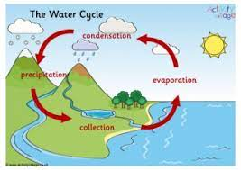
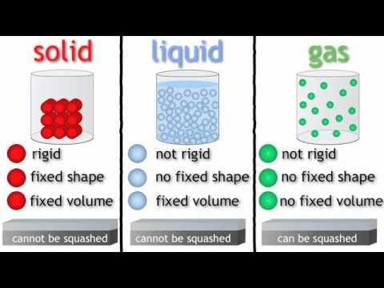
Key Vocabulary
states of matter | Materials can be one of three states: solids, liquids or gases. Some materials can change from one state to another and back again.
solids | Solids are materials that keep their shape unless a force is applied to them. They can be hard, soft or even squashy. Solids take up the same amount of space no matter what has happened to them.
liquids | Liquids take the shape of their container. They can change shape but do not change the amount of space they take up. They can flow or be poured.
gases | Gases can spread out to completely fill the container or room they are in. They do not have any fixed shape but they do have a mass.
melt | When a solid changes to a liquid.
freeze | When a liquid changes to a solid.
evaporate | When a liquid turns into a gas.
condense | When a gas turns into a liquid.
precipitation | Liquid or solid particles that fall from a cloud as rain, sleet, hail or snow.
water vapour | Water in the form of a gas.
Key Learning
Compare and group materials together according to whether they are solids, liquids or gases.

Particles in a solid are close together and cannot move; they can only vibrate.

Particles in a liquid are close together but can move around each other easily.

Particles in a gas are spread out and can move around very quickly in all directions.

If a solid is heated to its melting point, it melts and changes to a liquid.

If a liquid is cooled to its freezing point, it freezes and changes to a solid.

When water is heated, it evaporates and turns into water vapour.

Heat speeds up evaporation.

When water vapour is cooled, it condenses and turns into liquid water.

The water cycle is the continuous movement of water within the Earth and atmosphere.

Are you a Milecastle Megamind?

What are the best conditions for drying washing?

Can you explain the water cycle?

Can you describe the different properties of solids, liquids and gases?

Where is the source of the River Tyne?

How are rivers used?

