
Year 4 Computing
Hardware Investigators

Key Vocabulary
components | Parts inside the computer casing.
CPU | The ‘brains’ of the computer, where all the calculations take place.
graphics card | Also known as a video card and used for displaying images.
hard drive | Where the computer stores all your documents, pictures, games and videos.
input | How information enters the computer.
motherboard | Main printed circuit board of the computer.
network card | Used to connect the computer to a network such as the Internet.
output | Where information leaves the system.
peripherals | Parts that are attached to the computer case.
RAM | Allows programs to store information to help the computer to run quickly.
software | The programs that run on the computer.
Key Learning
To understand the different parts that make up a computer.

To recall the different parts that make up a computer.

Are you a Milecastle Megamind?


What is the difference between hardware and software?

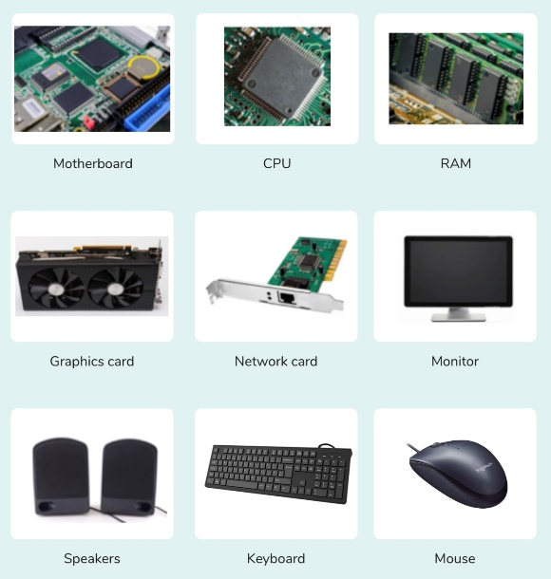

What is meant by onion skinning?

