
Year 4 Computing
Making Music

Key Vocabulary
BPM | Beats per minute. Changing the BPM changes the speed of the music.
dynamics | How loud or quiet a sound is.
harmonious | Notes which sound tuneful and pleasant together.
melody | A sequence of notes which make up a tune.
pitch | How high or low a sound is.
pulse | The steady beat of a piece of music.
rhythm | A pattern of long and short sounds and silences.
synths | Short for synthesizer. Electronic musical instrument sounds.
tempo | How slow or fast a piece of music is.
texture | The different sounds you can hear in a piece of music.
Key Learning
To identify and discuss the main elements of music.

To understand and experiment with rhythm and tempo.

To create a melodic phrase.
To electronically compose a piece of music.
Are you a Milecastle Megamind?

What is the difference between melody and rhythm?

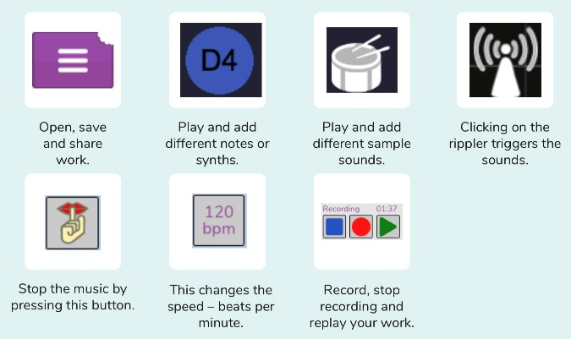


What is meant by onion skinning?

