
Year 5
GEOGRAPHY – What is a biome? Explore the rainforests

Key Vocabulary
rain forest | forests with tall trees, warm climates, and lots of rain.
climate | The average weather conditions  over a long period of time.
climate change | Long term changes in global temperatures.
deforestation | The cutting down and clearing  of forests.
equator | An imaginary circle running  round the centre of the earth.
tropic of cancer | an imaginary latitude line located above the equator
tropic of capricorn | an imaginary latitude line located below the equator
emergent layer | The top layer in the rain forest
canopy | A deep layer of vegetation below the emergent layer
understory | Warm damp layer below the leafy canopy
forest floor | The lowest layer where it is dark, hot and damp.
species | A group of similar animals  or plants
humidity | Feeling very damp due to water  vapour in the air.
Indigenous tribes | The original settlers of an area.
Key Learning
Explain what a biome is and identify and locate the world’s main biomes.o find out what a rainforest is and where they are
Identify and describe the flora and fauna of the main biomes of the world. How have they adapted to their environments?

Use maps, atlases and google earth to identify tropical rainforests around the world.
Describe and understand the physical features of the Amazon rainforest.
Find out about the indigenous tribes within the rainforest.
Describe the adaptation of animals and plants that live in the rainforest.

Apply knowledge to compare the Amazon rainforest to Sherwood or Keilder Forest.

Evaluate the threats to the Amazon Rainforest and justify the impact this will have on the wider world.
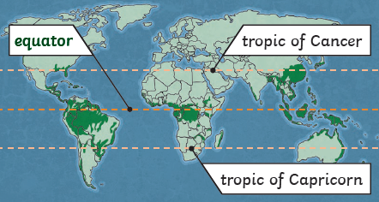

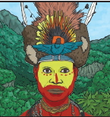
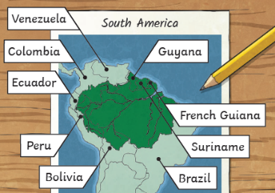

Why are the rainforests so important and how can we protect them?
Are you a Milecastle Megamind?

What is the impact of deforestation on people, plants and animals?
What are rain forests and where can they be found?

