
Year 5
SCIENCE -Living things and their habitats

Key Vocabulary
Asexual reproduction | One parent is needed to create an offspring, which is an exact copy of the parent.
fertilise | The action of fusing the male and female cells in order to develop an egg.
gestation | The length of a pregnancy.
Life cycle | The journey of changes that take place throughout the life of a living thing including birth, growing up and reproduction.
metamorphosis | An abrupt and obvious change in the structure of an animal’s body and their behaviour.
Pollination | The transfer of pollen to a stigma to allow pollination.
reproduction | The process of new living things being made.
Sexual reproduction | Two parents are needed to make offspring which are similar but not identical to the parent.
Key Learning
Describe the life process of reproduction in some plants and animals by exploring sexual reproduction in plants.
Describe how some plants reproduce.

Investigate plants in the rainforest and how they reproduce.
Describe the life cycle of a mammal by exploring the life cycles of mammals in the rainforest.
Describe the life process of reproduction in some plants and animals by describing sexual reproduction in mammals.

Describe the life process of reproduction in some plants and animals by exploring Jane Goodall’s work with chimpanzees.
Explain what Jane Goodall discovered about chimpanzees.
Describe the differences in the life cycles of an amphibian and an insect by exploring complete and incomplete metamorphosis.
Compare the life cycles of amphibians and insects.
Describe the differences in the life cycles of a mammal, an amphibian, an insect and a bird by describing and comparing different life cycles, including birds.

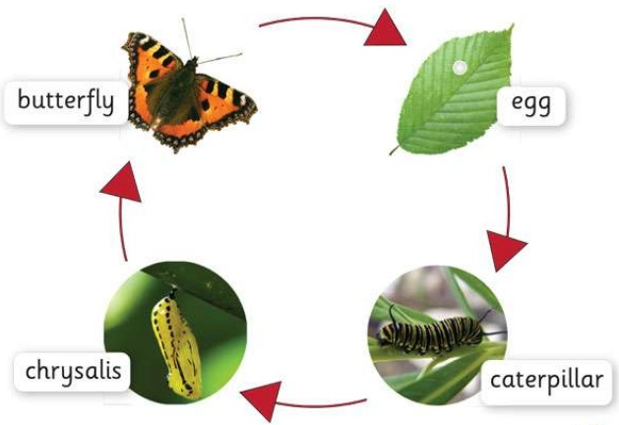
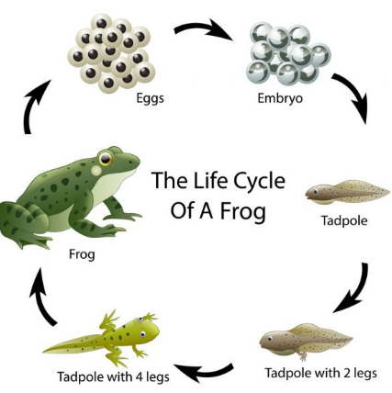
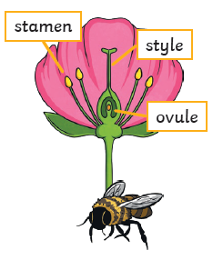
Are you a Milecastle Megamind?

Can you describe the differences in the life cycles of a mammal, an insect, a bird or an amphibian?
Can you explain how some plants reproduce?

Who was Jane Goodall and why was her work important?

